**User Manual for Establishment Registration in Pradhan Mantri Viksit Bharat Rojgar Yojna**

To avail the benefits under **Pradhan Mantri Viksit Bharat Rozgar Yojna**, establishments are required to complete a one-time registration process through the EPFO Employer Portal. This process involves furnishing GST and bank account details for verification, providing an undertaking, and digitally signing the declaration. The steps for registration are as follows:

**Step 1:**  
Employer shall visit Pradhan Mantri Viksit Bharat Rojgar Yojna portal (<https://pmvbry.epfindia.gov.in> or <https://pmvbry.labour.gov.in> ) and click on “Employer Login”. Employer will be redirected to EPFO Employer Portal.

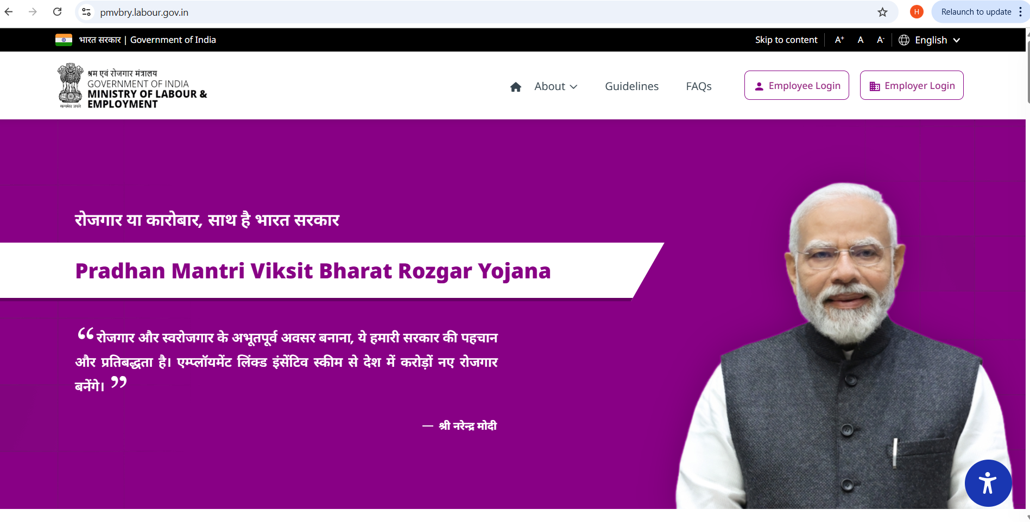

**Step 2:**

Employer would provide the credentials and CAPTCHA to login on EPFO Employer Portal

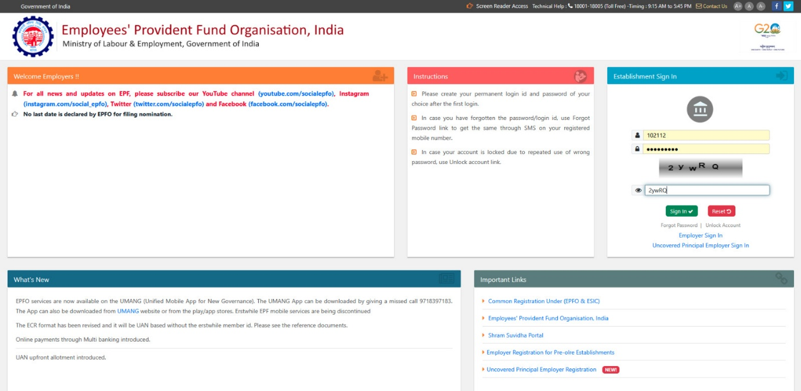

**Step 3:**  
After successful login, click on the **“PMVBRY”** tab on the homepage. Under this tab, select the option **“PART B Registration.”**

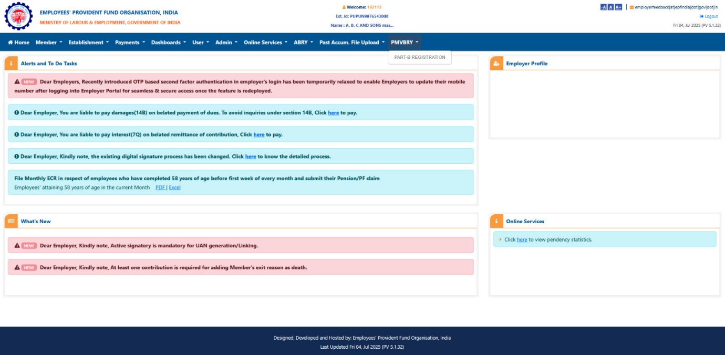

**Step 4:**  
System will prompt: *“Is the establishment registered with GSTN?”*  
Select **Yes** or **No** accordingly.

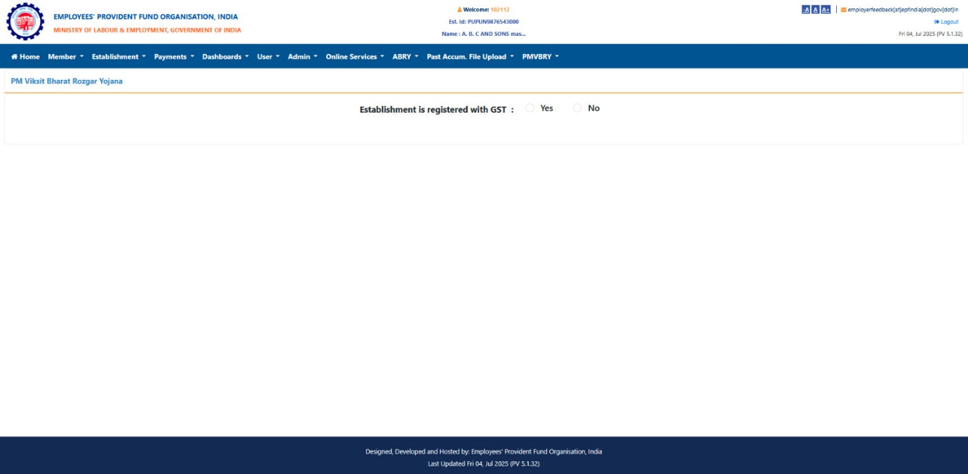

**Step 5:**

* If **No**, the employer must select a valid reason for not having GST registration from the drop-down list.
* 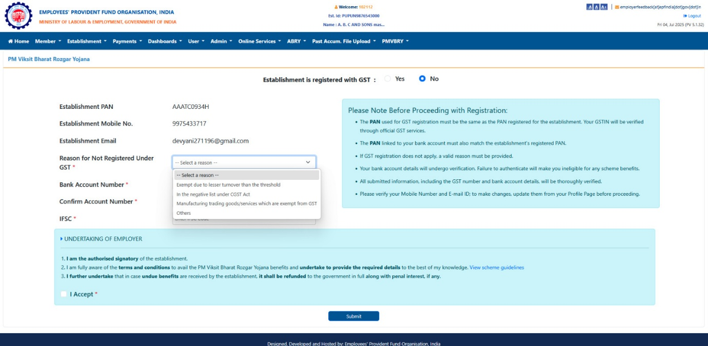
* If **Yes**, the employer must provide the following:
  + GST Registration Number
  + Establishment’s Bank Account Number
  + IFSC Code of the Bank

**Note:** The employer must ensure that the bank account is **linked with the PAN of the establishment** in the bank’s records. Both **GST** and **bank details** will be verified through respective agencies (GSTN and Banks).

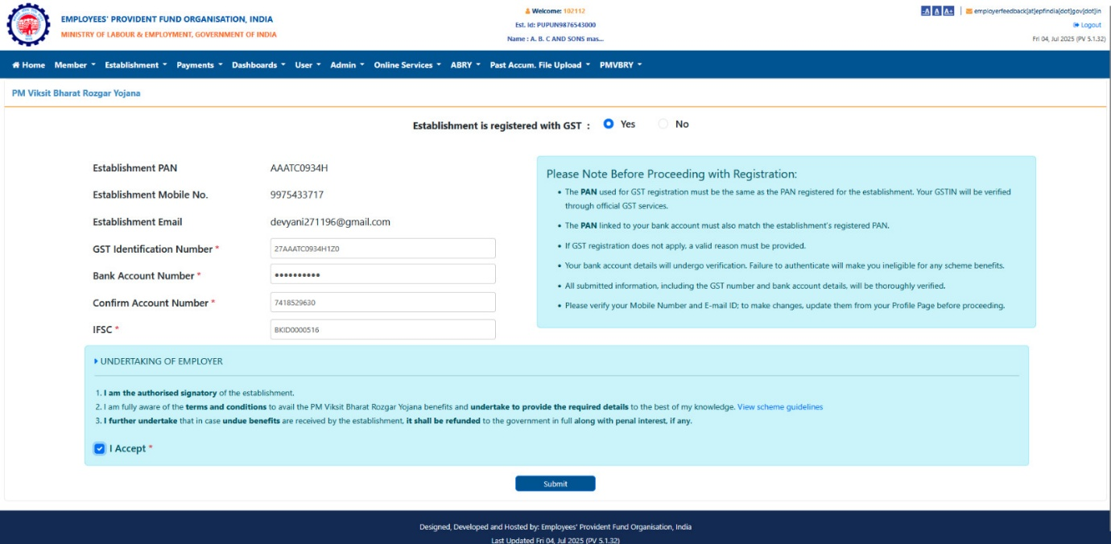

**Step 6:**  
After entering the details, the employer must accept the **undertaking** and click **Submit**.

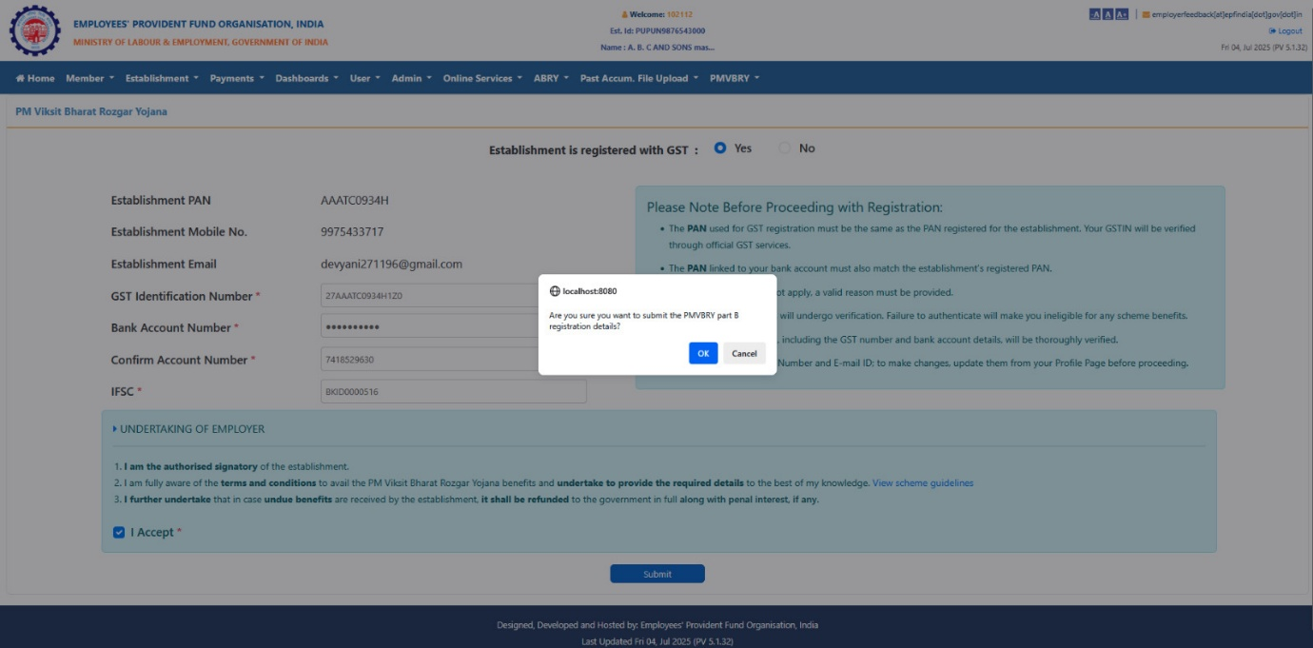

**Step 7:**  
Post submission, the employer is required to **approve the details** using **e-Sign** or **Digital Signature Certificate (DSC).**

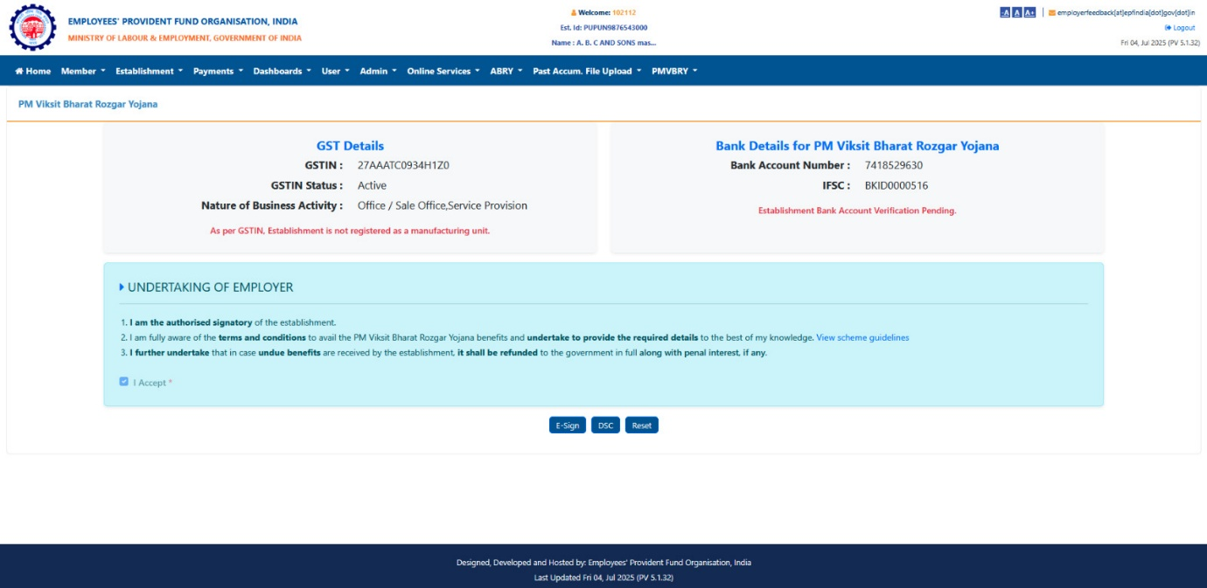

**Step 8:**  
Upon successful e-Sign/DSC, the **registration process is complete**. The employer can **download the undertaking PDF** for records.

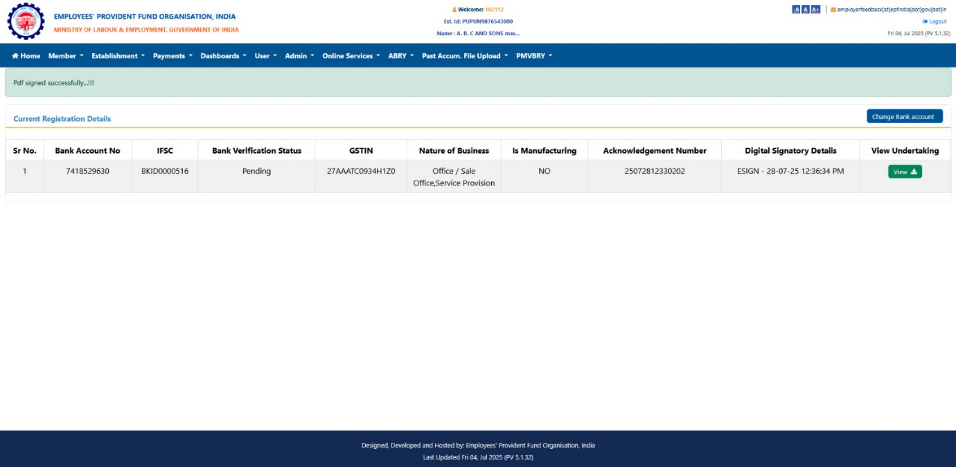

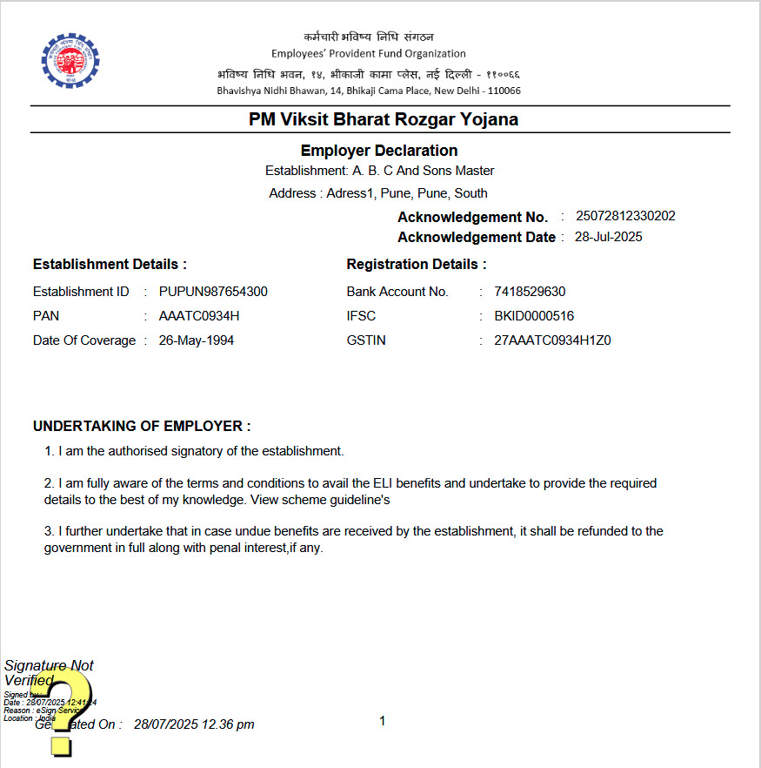

**Step 9 (If Applicable):**  
In case the bank account details are found to be invalid or the bank account is later changed, the employer can update the same by:

* Clicking on **“Change Bank”**
* Providing new bank account details
* Approving it again through **e-Sign** or **DSC**